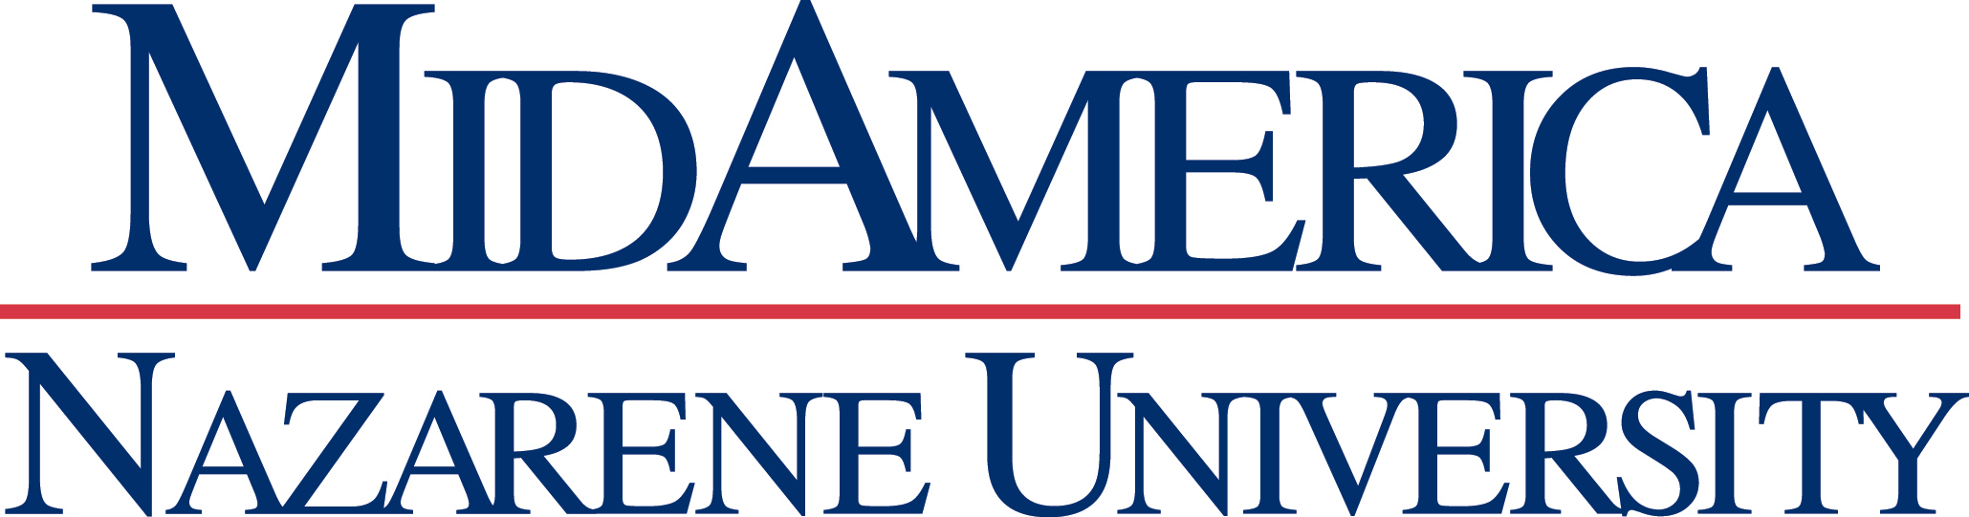
Master of Arts in Counseling
Program Outcomes 2022-2023
Specialty Track | Number of 2023  Graduates | Pass Rates for National Counselors Exam | Program Completion Rates | Job Placement Rates
Marriage, Couple & Family | 25 | 88% | 90% | 96%
Mental Health | 17 | 82% | 85% | 85%
School Counseling | 10 | 100% | 77% | 100%

